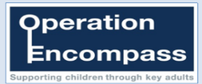
Bramley Sunnyside Infant School Newsletter 28 Spring Term
Thursday 9th April 2020

All the following information can be found on the following:
@bramleyinfant www.bramleysunnysideinfant.co.uk

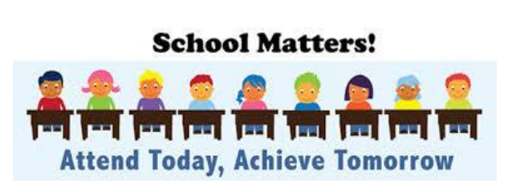

Keep Social Distancing!
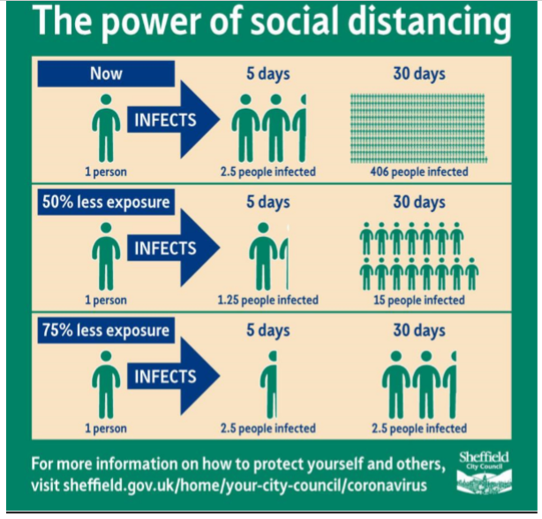
This picture demonstrates how just socially distancing yourself and others can have a dramatic effect in stopping the spread and protecting others. It has been suggested that given we do not yet have a vaccine and we need to slow the spread of the virus, maintaining a physical distance is effectively the next best thing in helping break the person to person infection.
Children/young people will pester to go out and socialise with their friends, they are kids and will want to do what kids do in their normal daily lives. However, over the coming weeks you need to make sure that the only physical social contact they have is with immediate family.

Government Announcement regarding Free School Meal Vouchers
During these challenging times, the government wants to ensure that pupils eligible for a benefit related free school meal can continue to access support if they are not in school. In the first instance, schools are asked to provide a lunch through their current school meal provider. We have notified all parents of eligible children that ‘grab bag ‘lunches are available for collection at school each day.
However, the uptake has been very low and we are aware that many families may self-isolating or social distancing as much as possible and therefore not able to come and collect them.
This Thursday, we were able to register via the Government’s online portal. We understand that an e-code will then be issued which we will E Mail to families. Parents or adults with caring responsibilities for the eligible child will then go on line to redeem the eCode against a choice of gift cards (a digital gift card delivered via email) which currently includes the following food retailers:
Morrisons, Tesco, Sainsbury’s, Asda, Waitrose and M&S food.
We will contact eligible families as soon as we have this information.

If your circumstances have changed and you feel that your child may now be eligible for a benefit free school meal, please see information below on how you can apply.

Benefit Related Free School Meals – Am I eligible?
Am I Eligible to Apply for Benefit Related Free School Meals and therefore be eligible for FSM (Free School Meals) vouchers each week?
If as parents/carers you receive one of the following, you may be able to claim for benefit related Free School Meals and the benefits this brings including free activities
· Income support
· Income Based Jobseekers’ Allowance
· Income-related Employment and Support Allowance
· Support under part VI of the Immigration and Asylum Act 1999
· The Guaranteed element of State Pension Credit
· Child Tax Credit, provided you are not also entitled to Working Tax Credit, and have an annual income, of no more than £16,190 (as of 2014 financial year) as assessed by Her Majesty’s Revenue and Customs
· Working Tax Credit run-on - paid for four weeks after you stop qualifying for Working Tax Credit
Free School Meals Helpline – 01709 336066. The Free School Meals Team can assess your claim using an eligibility checker to confirm entitlement. Applications can be made over the phone or by accessing the following link: http://www.rotherham.gov.uk/info/200008/benefits_and_support/104/apply_for_free_school_meals
Supporting Children’s Well being

Rotherham’s SEND Local offer website has a whole host of resources that you can access as a parent to support your children. Whilst they have valuable resources for children with SEND, they also have lots of practical activities that ALL children can do. Take a look at their website for further information.
http://www.rotherhamsendlocaloffer.org.uk/info/18/education_and_childcare/142/support_for_families_with_children_off_school

Supporting Parent’s Well-being.
‘Action for happiness’ have a website which can be found at https://www.actionforhappiness.org/.
It includes You tube talks from inspiring speakers, a free ten days of happiness Email coaching programme and also a Coping calendar packed with suggestions (see below).

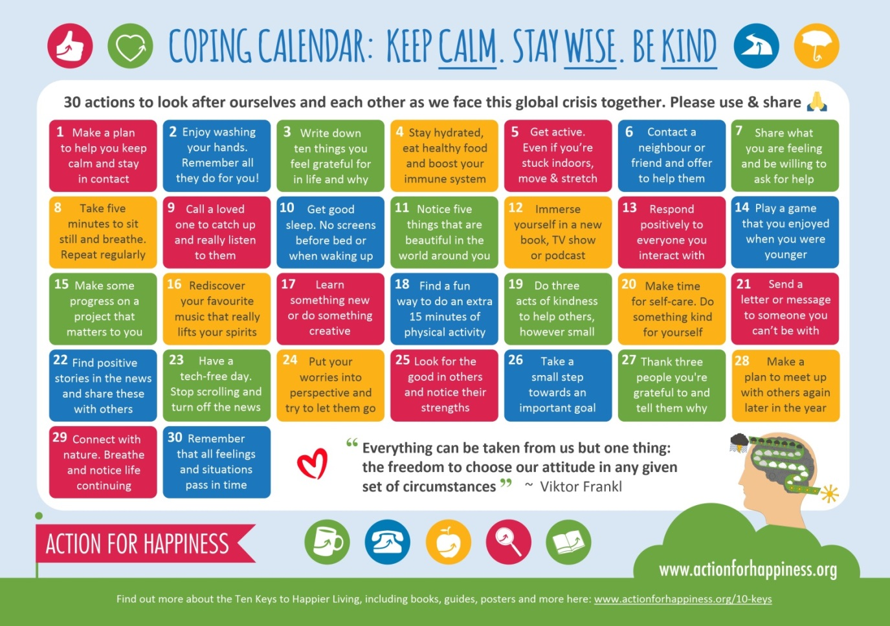

The Arts Council have collated a range of free online family activities that i

Home learning

Re-discover your home as a creative space!
‘A new direction’ has lots of ideas of how to use your home as an inspiration for creative activities.
Why not try their treasure Hunt? There are clues already written for you!
Are you crazy about dinosaurs – create your very own sketch staring with a pair of socks! See the ‘Sunday Sketches’ section for more details
You may want to try the Page 10 challenge – collecting 10 books and choosing a sentence from each to put together into a story. Or you may want to spread joyful and encouraging messages around the house for others to find!
https://www.anewdirection.org.uk/blog/keeping-creative-at-home-rediscover-your-home-as-a-creative-space?dm_i=33P2,10XAH,5GBL9L,3WGEO,1

Tate Galleries
The Tate Galleries may be closed for the first time in it’s history, but they have brought a wealth of creative children’s activities on line at https://www.tate.org.uk/kids?dm_i=33P2,10XAH,5GBL9L,3WGBJ,1
There are lots of fun ideas to get your children making, experimenting and learning!

The Arts Council
The Arts Council have collated range of free online family activities that include Music, theatre, dance, art and even a bit of cooking! There are free West End shows to watch, word searches to solve, ballet lessons to join… the possibilities are endless! Take a look at…
https://fantasticforfamilies.com/news/1067/2020-03-23/10-creative-at-home-activities-for-families?dm_i=33P2,10XAH,5GBL9L,3WFOI,1

The Library Service
The library service would like to invite you all to use and join in with their Library online resources, They have lots of exciting activities available now.
They are also running weekly live Rhymetime sessions for under 5’s or anyone who wants to join in on Tuesday afternoons at 2.30. Just log into our Rotherham Libraries Facebook.
Find attached details of a special creative writing challenge which is now up and running! You can join in and comment with the new Facebook group
https://www.facebook.com/groups/542762703090639/?source_id=40005831989
More useful resources are being added weekly for children during this time can be found on the Rotherham Libraries webpage https://www.rotherham.gov.uk/libraries/online-library/2?documentId=580&categoryId=20088 or by following Rotherham Libraries on Facebook and Twitter.
Check out their weekly Lego challenge via their Facebook page!
This week’s craft activities are a fabulous T-shirt bag and desk tidy all recycling and sustainable!
The team have been working on some story reading videos which should be up and running on their Rotherham Libraries web page from next week. There will be a different story to join in with each week.

We have received calls from some parents worried if they are ‘getting it right’.
YOU ARE!
You are there for your children, physically and emotionally.
The most important thing you can do is…
- keep as much of a routine as possible
- enjoy this time together – it is an opportunity to make lasting memories
- try the learning activities we send home, but not in a way that negatively affects your well-being. Little and often.

Remember, you are doing a FANTASTIC JOB!

Take Care and HAPPY EASTER!

The Staff at Bramley Sunnyside Infant School
x

