Year Two Home Learning Summer 1 Week 1
Reading Tasks
- Share a text EVERY DAY, even if it’s just for 5 minutes! Use the weblinks below for thousands of free books online. Use the questions on your Year 2 bookmark.
- Make some Year 2 common exception word flash cards (choose the ones that sometimes catch you out). How many can you read in 1 minute? Can you improve your score each day?

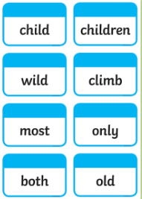
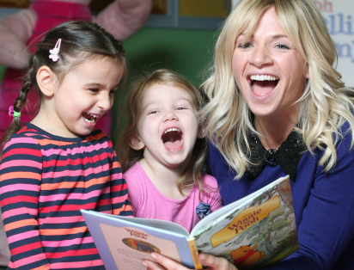.
- Download the ‘Birds in your Garden’ reading comprehension attached. There are 3 texts and question sets. If your child is reading Read, Write, Inc. books or green band, please complete the text with one star at the bottom of the page. If your child reads orange, turquoise or purple books, please complete the text with two stars. If your child reads gold, white or lime books, please complete the text with three stars. Remember to find the ‘proof on the page’ when you answer the questions.

Tips for parents/carers Web links
Phonics
- Read aloud to your child, letting your child sit back and enjoy the book.
- Show your child that you love to read too. Let them catch you relaxing with a book! Show them that reading is for adults, as well as children.
- Watch author retellings online. There are so many available to watch on YouTube!
- Brand new books and other phonics resources have been uploaded onto Oxford Owl, including the Read, Write, Inc. book bands. This will really support your child’s word-reading and help to move their reading on.
- Visit www.oxfordowl.co.uk to create your own free parent account.

https://www.getepic.com/
https://www.topmarks.co.uk/english-games/5-7-years/stories
https://www.worldofdavidwalliams.com/elevenses/
https://www.booktrust.org.uk/books-and-reading/bookfinder/
https://www.lovereading4kids.co.uk/
https://childrens.poetryarchive.org/

As well as Read, Write, Inc. books, Ruth Miskin has also uploaded the following
phonics resources onto www.oxfordowl.co.uk:
Speed sound practice sheets, speedy green word slide shows and speed sound slide shows.

Practise reading and spelling words with split digraphs (a_e, e_e, i_e, o_e, u_e)
You will find the visual images for these sounds in your home school diary.
a_e (make a cake)
e_e ( Pete and Steve)
i_e (nice smile)
o_e (phone home)
u_e (huge brute)
E.g. flake, these, chime, phone, huge

Focus on one sound each day of the week

SPaG (Spelling, Punctuation and Grammar)
Can you change these present tense verbs into the past tense? We use the past tense when something has already happened.
E.g. jump jumped
Usually, we just add the suffix -ed to change the verb to the past tense.
Can you change these verbs to the past tense by adding -ed?
trick smash bump call look lick pick stamp lift push pull watch follow laugh scratch pack
Can you write some sentences including some of these words?
Challenge: Can you extend your sentence using a coordinating conjunction (and, but, or, so) or a subordinating conjunction (because, if, when, until)?
E.g. Yesterday I bumped my head but it didn’t hurt.

Writing
Write a letter to somebody who you miss. Tell them what you’ve been doing to keep busy and ask them some questions as well. Remember to use full stops, question marks and capital letters correctly.
When you write their address, remember names of people and places begin with a capital letter.
Show them your most beautiful handwriting.
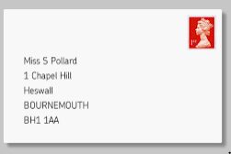
Challenge: Can you include conjunctions to extend your sentences to give more detail for the reader? (and, but, or, so, because, when, if, until)

Maths /Art link
Make a pictorial or practical number line by drawing pairs (e.g socks) Cut out the pair and hang/peg them on a washing line. Write the corresponding numbers for each pair as you count 2 4 6 etc up to 20.

Make a pictorial number line for fives. You could do handprints with paint or draw around and decorate hands and again write the corresponding numbers for each group of five 5 10 15 up to 50.

Make a pictorial number line for tens. You could use lego bricks 10 in each tower or potatoe print a flower with ten petals and again write the corresponding number for each group of ten ten 20 30 up to 100.
Challenge-Now try a threes and fours number line. What could you draw/print or make? Share some of your creations on twitter for us to see.

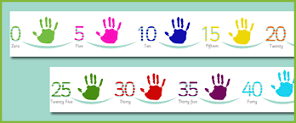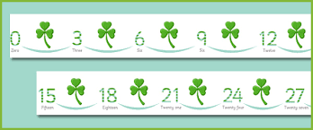

Science

Learn about habitats watching this you tube clip https://www.youtube.com/watch?v=ZrSWYE37MJs

Now watch it again and think about/discuss/write down-What is a habitat? -What must a habitat provide for the animals?

Foundation Subject
Geography-
Can you locate and find out about the Countries and Capital cities of the U.K? Use this web link
https://www.bbc.co.uk/bitesize/topics/zyhp34j/articles/z4v3jhv to play the cartoon clip, look at the photographs and do the labelling activities for the countries and capital cities of the U.K.

Physical Education – Speed & Agility
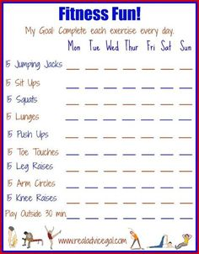
1. Shuttle Run- from starting position run to closest cone then back to start, then to middle cone and back to start, then to final cone and all the way back. Repeat/change the order, time it and compete with family.
2. Fitness Tracker, there are 10 exercises to do per day (Tick a box to say you have done it or write in your score of how many they can do in a set time frame. E.g. jumping jacks in 30 seconds.

Website of the Week
Log in to become a member to discover some great books and phonics resources www.oxfordowl.co.uk

Please use the following website to access any learning set on Espresso
https://www.discoveryeducation.co.uk/what-we-offer/discovery-education-espresso
The login details are as follows:
Username: student27402
Password: bramley

