Year One Home Learning Summer 1 Week 1
Reading Tasks
- Share a text EVERY DAY, even if it’s just for 5 minutes! Use the weblinks below for thousands of free books online.
- Talk with your grown-up/brother/sister about the text using the questions on your Year 1 bookmark.
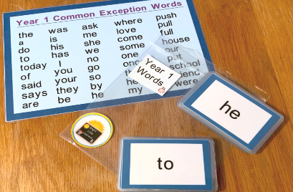


- Make some common exception word flash cards. How many can you read in 1 minute? Can you improve your score daily?
- Draw the main characters from the book. Discuss what they looked like and how they behaved in the story. At different points throughout the story how did the characters feel and why? Were they a good or bad character? How do you know?

Tips for parents/carers Web links
https://www.getepic.com/
https://www.topmarks.co.uk/english-games/5-7-years/stories
https://www.worldofdavidwalliams.com/elevenses/
https://www.booktrust.org.uk/books-and-reading/bookfinder/
https://www.lovereading4kids.co.uk/
https://childrens.poetryarchive.org/

- Read aloud to your child, letting your child sit back and enjoy the book.
- Show your child that you love to read too. Let them catch you relaxing with a book! Show them that reading is for adults, as well as children.
- Watch author retellings online. There are so many available to watch on YouTube!
- Brand new books and other phonics resources have been uploaded onto Oxford Owl, including the Read, Write, Inc. book bands. This will really support your child’s word-reading and help to move their reading on.
- Visit www.oxfordowl.co.uk to create your own free parent account.

.
Phonics
Go on a sound hunt.
As well as Read, Write, Inc. books, Ruth Miskin has also uploaded the following
phonics resources onto www.oxfordowl.co.uk:
Speed sound practice sheets, speedy green word slide shows and speed sound slide shows 
Make sound cards (ea, oi, a_e, i_e, o_e and u_e)
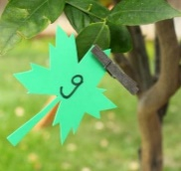
Peg them around your garden or in your house and see how many you can find in 1 minute.
Off you go!

SPaG (Spelling, Punctuation and Grammar)
What is a verb?
A verb is an action word. E.g. kick, throw, catch, jump, sit, eat.
They can come in different forms. E.g. walk, walking, walked
Act out a verb. Can a family member guess what the verb is? Now swap roles.

Writing

Write down 3 lovely things you would like to do in the future.
e.g. Have a posh meal with my family.
Visit the zoo and see my favourite animals.
Don’t forget to add some beautiful pictures too!

Maths
- BBC Bitesize – Maths Lesson of the day Monday to Friday
- Choose a number between 1 and 20. Write the number as a numeral and in words. Go on a treasure hunt to find this many objects that are green in your house/garden. Check you have the correct total. Put the items in groups of 2. Is it an odd/even number? How many different ways can you sort the items into two groups?

- In the garden hunt for as many sticks as you can find/use pencils. Which 2D shapes can you make? Can you name them? How many sides and vertices does each shape have? Using the sticks and elastic bands, can you make a 3D shape? How many edges/vertices does it have?
- Go on the Espresso Discovery Website and click on KS1 and then the Maths section and click on the addition and subtraction option. Play darts/lotto/addition and subtraction activities/word problems
- Map out a maze in the garden/living room with masking tape/chalk/string. Put on a blindfold on and ask your adult to guide you along your course by giving instructions including full turn/half turn/quarter turn/forwards/backwards/sideways etc. Use the maths resources and watch the video on espresso (Position and direction) first if this is needed. Ask your adult to put a small treat at the end of the course if you manage to follow the instructions correctly. Swap over and give your adult instructions on how to complete the course. If they manage this successfully give them a token with a promise to help them with a household chore.
- During your daily exercise, track the even numbers on one side of the street on the way out and the odd numbers on the way back. What will the next odd number be? What is the previous even number? When you are counting in odds and evens what unit are you counting in?
- Start to save cardboard boxes of all sizes for future use.
Science

Espresso KS1 > Science > Plants
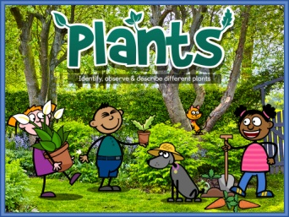
As we’re officially in Spring and all the lovely plants are flowering can you watch the videos on plants and complete the plant quiz? How many did you get correct?

Foundation Subject
Go to the Espresso Discovery website and watch the KS1 weekly news. Make this a weekly event where you listen to news together and chat about what you have learned.
History
Go to the Espresso Discovery website and click on KS1 History.
Click on The Great Fire Of London section.
Read one of the books and watch one of the videos explaining what happened during the Great Fire of London.
Complete the Old and New activity and have a go at the Quiz to see how much you can remember about the event.
Imagine you are Samuel Pepys writing an entry in your diary about what you witnessed. What did you see? What could you smell? How did you feel?

Physical Education -Dance
Go to the Espresso Discovery website and click on the KS1 PE section. Select the Street Dance option.
Each day learn and practise a different part of the dance using the videos which are broken down into sections. On Friday complete the review and prepare to perform your street dance to your family.
Create a safe place to perform making sure enough space. Prepare a name for your dance and introduce your dance as though you were on X Factor. Ask your family to watch and be ready to critique your dance. Perform your dance for your family and ask them for constructive feedback!
Website of the Week
Log in to become a member to discover some great books and phonics resources www.oxfordowl.co.uk


Please use the following website to access all the learning set on Espresso
https://www.discoveryeducation.co.uk/what-we-offer/discovery-education-espresso
The login details are as follows:
Username: student27402
Password: bramley

